Project Report
on
Banking Analytics using SQL & Power BI

Submitted by,
Pavithra Kasinathan Selvavinayagam

Table of Contents
- Introduction
- Project Objective
- Dataset Overview
- Methodology
- Data Preparation
- KPI Analysis
- Dashboard Screenshots
- Business Insights
- Recommendations
- Conclusion

- INTRODUCTION
Every day, the banking industry generates a vast amount of data through customer registrations, account management, financial transactions, loan processing, card issuance, and merchant payments. Analysing this data helps banks understand customer behavior, monitor financial performance, identify growth opportunities, and make informed business decisions.
This project focuses on analysing a comprehensive banking dataset consisting of seven interconnected datasets representing the core operations of a retail banking system. The datasets include customer information, account details, transaction history, merchant information, loan portfolio, card details, and branch information. Together, these datasets provide a complete view of customer banking activities and financial operations.
The project utilizes MySQL to perform data preparation, aggregation, and analytical queries for extracting meaningful business insights. Power BI is then used to build interactive dashboards that transform the analytical results into visually intuitive reports for business users.
The analysis covers multiple business areas including customer analytics, account performance, transaction trends, merchant performance, and loan portfolio analysis. Key Performance Indicators (KPIs), trend analysis, customer segmentation, merchant rankings, and lending insights are generated to evaluate overall banking performance.
The primary objective of this project is to convert raw banking data into actionable insights that support strategic decision-making. By identifying customer behaviour patterns, monitoring transaction activities, evaluating merchant contributions, and analysing lending performance, the project demonstrates how data analytics can help financial institutions improve customer satisfaction, optimize operations, strengthen merchant partnerships, and enhance overall business performance.
The project is divided into four major analytical areas: Executive Overview, Customer Analytics, Account & Transaction Analytics, and Merchant & Loan Analytics. These analyses are supported through SQL queries, DAX calculations, and interactive Power BI dashboards, providing a comprehensive overview of the bank's operational and financial performance.

- PROJECT OBJECTIVE

The primary objectives of this Banking Analytics project are:
- To analyze banking data using SQL to extract meaningful business insights from customer, account, transaction, merchant, loan, and card datasets.
- To perform data preparation, validation, and aggregation to ensure accurate and reliable analysis.
- To evaluate customer demographics, registration trends, credit score distribution, and banking product ownership.
- To analyze account performance, transaction trends, and customer transaction behavior over time.
- To identify high-value customers, top-performing merchants, and major contributors to the bank's transaction volume.
- To assess the bank's loan portfolio by analysing loan distribution, interest rate segments, and customer borrowing patterns.
- To design interactive and user-friendly Power BI dashboards for effective visualization of key banking performance indicators.
- To generate actionable business insights and recommendations that support customer management, account optimization, merchant partnerships, loan portfolio monitoring, and overall banking performance improvement.
- DATASET OVERVIEW
This project utilizes a comprehensive banking dataset consisting of seven interconnected tables representing the major operational areas of a retail banking system. The datasets capture customer information, account details, transaction history, merchant information, loan portfolio, card details, and branch information. These datasets are connected using primary and foreign keys, enabling relational analysis across multiple banking operations.
The banking dataset allows analysis of customer behavior, account activity, transaction patterns, merchant performance, and lending operations through SQL queries and interactive Power BI dashboards.
3.1 DATASET SUMMARY
Dataset | Description | Key Fields
Customers | Stores customer demographic and registration information. | Customer ID, First Name, Last Name, Email, City, Credit Score, Registration Date
Accounts | Contains bank account details linked to customers. | Account ID, Customer ID, Account Type, Account Balance, Account Opening Date
Transactions | Records financial transactions performed through customer accounts. | Transaction ID, Account ID, Merchant ID, Transaction Amount, Transaction Date
Merchants | Stores information about merchants involved in customer transactions. | Merchant ID, Merchant Name, City
Loans | Contains customer loan details including loan amount and interest rate. | Loan ID, Customer ID, Loan Amount, Interest Rate, Loan Start Date
Cards | Stores debit and credit card information associated with customer accounts. | Card ID, Account ID, Card Type, Expiration Date
Branches | Contains branch information and branch manager details. | Branch ID, Branch Name, Manager Name

3.2 RELATIONSHIP BETWEEN DATASETS
The datasets are linked through primary and foreign keys, allowing data from multiple business areas to be analyzed together.
Relationship | Description
Customers → Accounts | One customer can own one or more bank accounts.
Accounts → Transactions | Each account can have multiple financial transactions.
Transactions → Merchants | Every transaction is associated with a merchant.
Customers → Loans | A customer may have one or more loans.
Accounts → Cards | A bank account may have one or more associated cards.
Branches | Stores branch information independently and serves as a reference dataset in this project.

The relational structure of the dataset enables comprehensive analysis across customer, account, transaction, merchant, and loan domains. These relationships support integrated SQL analysis and interactive Power BI visualizations, allowing business performance to be evaluated from multiple perspectives.
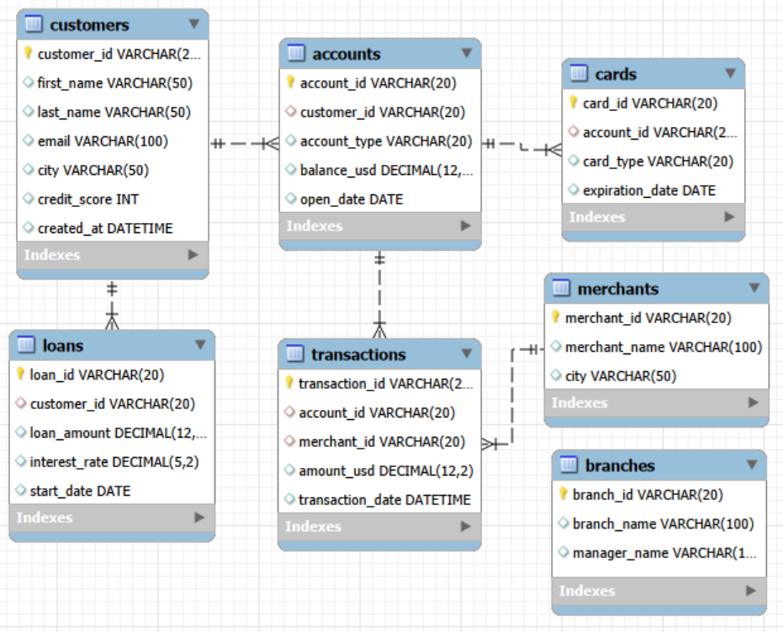
Fig 3.2 Entity Relationship Diagram (ERD) of the Banking Dataset

- METHODOLOGY
The Banking Analytics project followed a structured workflow to transform raw banking data into meaningful business insights. The methodology consisted of data collection, pre-processing, SQL-based analysis, dashboard development, and interpretation of results to support business decision-making.

Fig 4.1 Project Methodology

4.1 METHODOLOGY STEPS

1. Data Collection
Collected seven banking datasets containing customer, account, transaction, merchant, loan, card, and branch information for comprehensive banking analysis.

2. Data Import
Imported the datasets into MySQL and organized them into relational database tables for efficient querying and analysis.

3. Data Preparation
Validated data quality, established table relationships, and prepared the datasets for accurate SQL analysis and visualization.

4. SQL Analysis
Performed analytical queries to evaluate customer behavior, account performance, transaction trends, merchant performance, and loan portfolio metrics.

5. Power BI Dashboard Development
Developed interactive dashboards using DAX measures, calculated columns, and visualizations to present key performance indicators and analytical findings.

6. Business Insights
Interpreted analytical results to identify patterns, trends, and opportunities across customer, transaction, merchant, and loan data.

7. Business Recommendations
Provided data-driven recommendations to improve customer management, account utilization, transaction monitoring, merchant partnerships, and lending strategies.

- DATA PREPARATION

5.1 Overview
Before performing SQL analysis and developing interactive dashboards, the banking datasets were prepared to ensure data accuracy, consistency, and integrity. Data preparation involved importing the datasets into MySQL, validating data quality, performing consistency checks, creating derived attributes for time-based analysis, and verifying the data model in Power BI. These pre-processing steps ensured reliable analysis and accurate dashboard reporting.

5.2 SQL Data Preparation

5.2.1 Data Import
- Imported the seven banking datasets into MySQL Workbench.
- Created relational database tables for Customers, Accounts, Transactions, Merchants, Loans, Cards, and Branches.
- Verified successful data import by validating the number of records in each table.

5.2.2 Data Validation
To ensure the integrity of the banking database, the following validation checks were performed.

Primary Key Validation
Verified the uniqueness of:
- Customer IDs
- Account IDs
- Card IDs
- Loan IDs
- Transaction IDs
- Merchant IDs
to ensure duplicate records were not present.

Relationship Validation
Validated all primary and foreign key relationships to ensure referential integrity.
The following relationships were confirmed:
- Customers → Accounts
- Accounts → Transactions
- Transactions → Merchants
- Customers → Loans
- Accounts → Cards
This ensured that every analytical query returned consistent and reliable results.

5.2.3 Data Quality Assessment
The quality of important business attributes was assessed before analysis.

Customers
- Email
- City
- Credit Score
- Registration Date

Accounts
- Account Type
- Account Balance
- Account Opening Date

Cards
- Card Type
- Expiration Date

Merchants
- Merchant Name
- Merchant City

Loans
- Loan Amount
- Interest Rate
- Loan Start Date

Transactions
- Transaction Amount
- Transaction Date
The datasets were examined for missing values, incorrect data types, and invalid attribute values before proceeding with analytical queries.

5.2.4 Data Consistency Checks
Several business rule validations were performed to ensure logical consistency across the banking data.

Customer Data
- Checked for duplicate email addresses.
- Validated customer credit score ranges.
- Verified registration dates.

Account Data
- Checked for negative account balances.
- Verified that every account belongs to a valid customer.

Transaction Data
- Checked for negative transaction amounts.
- Verified that every transaction is linked to a valid account.
- Confirmed that every transaction is associated with a valid merchant.

Loan Data
- Validated interest rates.
- Checked loan start dates for future values.
- Verified that every loan belongs to a valid customer.

Card Data
- Verified that every card is associated with an existing account.

5.2.5 Derived Attributes for Analysis
To facilitate time-series analysis and support business reporting, derived date attributes were generated dynamically using SQL date functions during query execution. These attributes were not stored as permanent columns in the database; instead, they were created within SQL queries whenever required for analytical purposes.
The derived attributes enabled data aggregation at different time levels, making it easier to analyze trends, compare performance across periods, and prepare datasets for dashboard visualizations.
The following derived attributes were used during the analysis:

Customer Level
- Customer Registration Year
- Customer Registration Month
Purpose: Used to analyze customer acquisition trends and registration patterns over time.

Account Level
- Account Opening Year
- Account Opening Month
Purpose: Used to evaluate account opening trends and customer banking growth.

Transaction Level
- Transaction Year
- Transaction Quarter
- Transaction Month
- Transaction Day
- Transaction Weekday
Purpose: Used to analyze monthly transaction trends, seasonal patterns, weekday transaction behaviour, and transaction volume across different time periods.

Loan Level
- Loan Start Year
- Loan Start Month
Purpose: Used to study lending trends, loan disbursement patterns, and year-wise loan portfolio growth.
The derived attributes supported several SQL analyses, including customer registration trends, transaction trend analysis, merchant performance over time, and loan portfolio analysis. They also provided the temporal dimensions required for creating trend-based visualizations and filters in the Power BI dashboards.

5.3 Power BI Data Preparation
After completing SQL pre-processing and validation, the prepared banking datasets were imported into Power BI for data modelling and dashboard development.
The following preparation steps were performed in power BI:

5.3.1 Data Type Validation
The imported datasets were reviewed to ensure that each field was assigned the appropriate data type for accurate calculations and visualizations.
The following data types were verified:
- Date fields (Registration Date, Account Opening Date, Transaction Date, Loan Start Date, Card Expiration Date)
- Numeric fields (Account Balance, Transaction Amount, Loan Amount, Interest Rate, Credit Score)
- Text fields (Customer Name, Account Type, Merchant Name, City, Card Type)

5.3.2 Relationship Validation
The Power BI data model was verified to ensure that the relationships between the imported tables matched the relational database design established in MySQL.
The validated relationships included:
- Customers → Accounts
- Accounts → Transactions
- Transactions → Merchants
- Customers → Loans
- Accounts → Cards
These relationships enabled accurate cross-table analysis and interactive filtering across the dashboards.

5.3.3 Calculated Columns
To support categorical analysis and improve dashboard readability, the following calculated columns were created in Power BI:
Customer Table
- Credit Score Segment
- Credit Score Sort
Loan Table
- Interest Rate Segment
- Interest Rate Sort
These calculated columns grouped continuous numerical values into meaningful business categories, making it easier to analyze customer credit worthiness and loan distribution across different interest rate ranges.

5.3.4 Aggregated Measures and DAX Calculations
Several DAX measures were developed to calculate key performance indicators (KPIs) and business metrics used throughout the dashboards. These measures enabled dynamic calculations that responded to user interactions, filters, and slicers.
Power BI's built-in aggregation functions (Count, Distinct Count, Sum, Average) were used to calculate standard KPIs such as:
- Total Customers
- Total Accounts
- Total Transactions
- Total Transaction Volume
- Total Account Balance
- Total Loan Amount
- Average Credit Score
- Average Interest Rate
Additionally, custom DAX measures were developed for advanced business analysis, including:
- Customers with Multiple Accounts
- Customers with Cards
- Average Interest Rate %
These measures formed the analytical foundation of the interactive Power BI dashboards and ensured consistent reporting across all visualizations.

6. KPI Analysis

6.1 Overview
Key Performance Indicators (KPIs) were calculated using SQL to evaluate the bank's performance across customers, accounts, transactions, merchants, loans, and cards. These KPIs were then visualized in Power BI dashboards to enable interactive analysis and support business decision-making.

6.2 SQL KPIs
The following KPIs were generated using SQL:

Category | KPIs
Customer | Total Customers, New Customers, Average/Highest/Lowest Credit Score, Customers by City, Customers by Credit Score Range
Account | Total Accounts, Total/Average/Highest/Lowest Account Balance, Accounts by Type, Average Balance by Account Type
Transaction | Total Transactions, Total Transaction Volume, Average/Maximum/Minimum Transaction Amount, Monthly & Yearly Transaction Volume
Merchant | Total Merchants, Total & Average Transaction Value by Merchant, Top Performing Merchants, Merchant Distribution by City
Loan | Total Loans, Total/Average/Highest/Lowest Loan Amount, Average Interest Rate
Card | Total Cards Issued, Card Distribution by Type, Cards Expiring by Year

6.3 Power BI KPIs
Power BI was used to present key banking metrics through interactive KPI cards and visualizations. Standard aggregation functions and DAX calculations were used to summarize the data and provide an overall view of banking performance across customers, accounts, transactions, merchants, and loans.
The primary KPIs displayed across the dashboards are summarized below:
Dashboard | Key KPIs
Executive Overview | Total Customers, Total Accounts, Total Transactions, Total Transaction Volume, Total Account Balance, Total Loan Amount, Average Credit Score
Customer Analytics | Total Customers, Total Loans, Customers with Multiple Accounts, Customers with Cards, Average Credit Score
Account & Transaction Analytics | Total Accounts, Total Account Balance, Total Transaction Amount, Average Transaction Amount
Merchant & Loan Analytics | Total Merchants, Total Loans, Total Loan Amount, Average Interest Rate

7. Dashboard Screenshots

7.1 Executive Overview
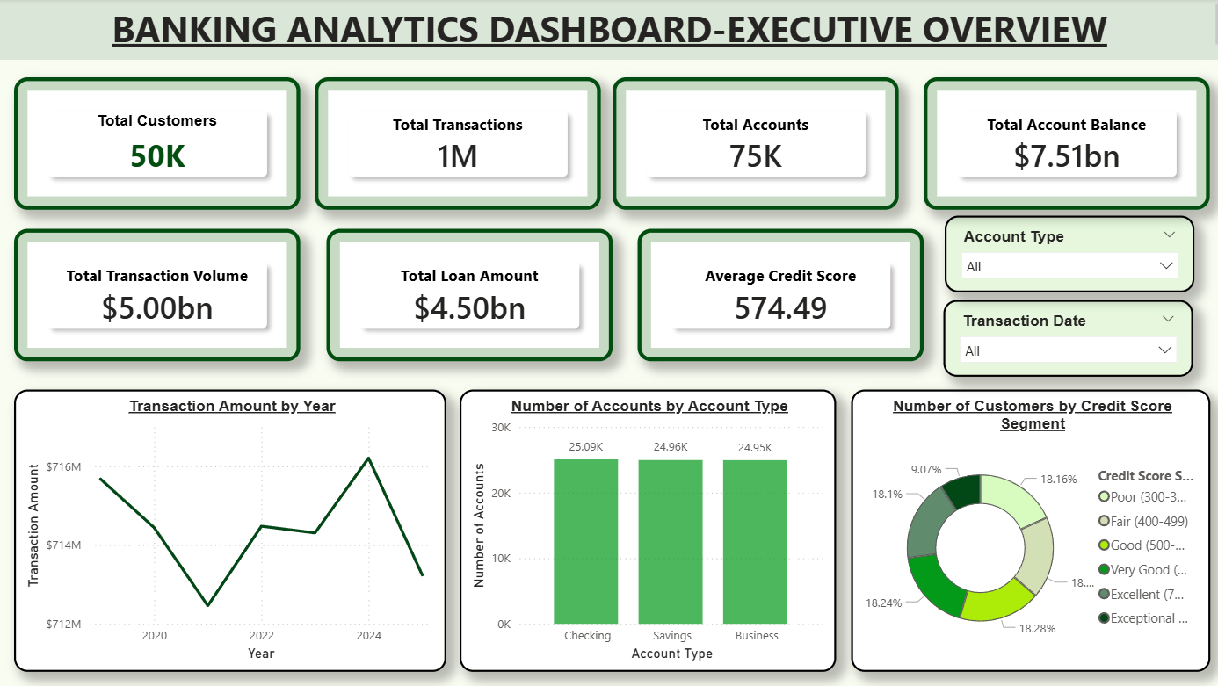
Figure 7.1: Executive Overview Dashboard
Description: Provides a high-level summary of the bank's overall performance through key KPIs, account distribution, and credit score segmentation.
7.2: Customer Analytics Dashboard
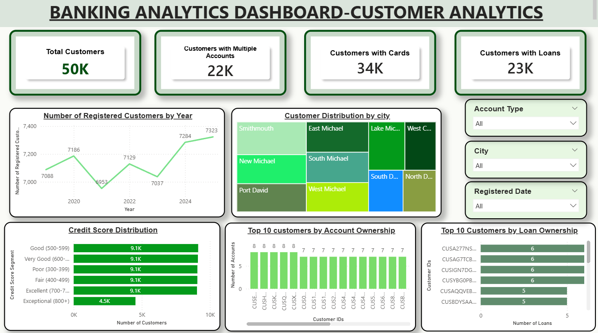

Figure 7.2: Customer Analytics Dashboard
Description: Presents customer demographics, registration trends, account ownership, credit score distribution, and customer segmentation to better understand customer behavior.
7.3: Account & Transaction Analytics Dashboard
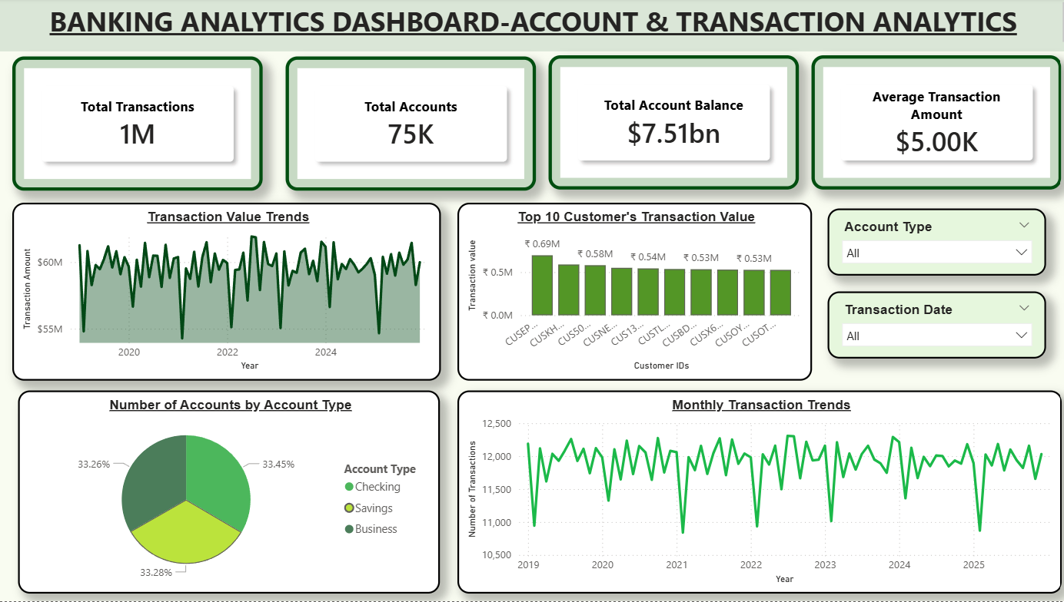

Figure 7.3: Account & Transaction Analytics Dashboard
Description: Analyzes account performance and transaction activity through account balances, transaction trends, account types, and high-value customer insights.
7.4: Merchant & Loan Analytics Dashboard
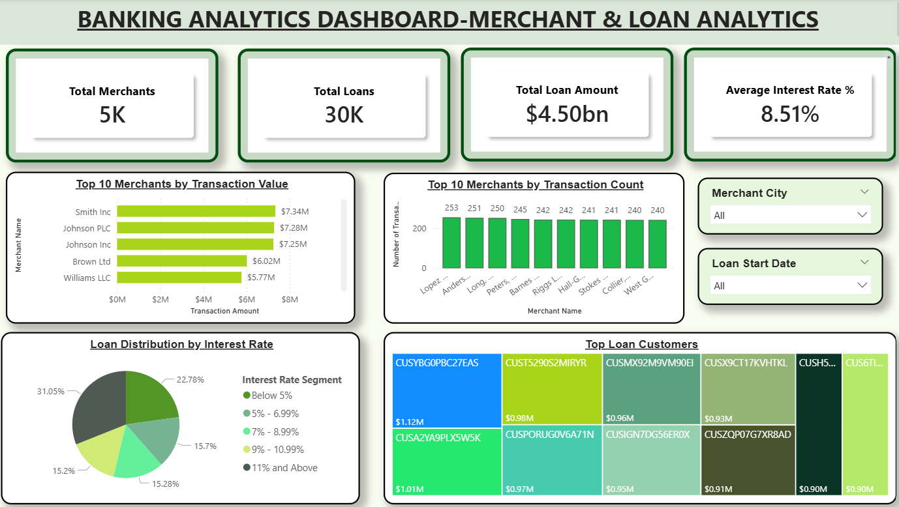

Figure 7.4: Merchant & Loan Analytics Dashboard
Description: Provides insights into merchant performance, loan portfolio distribution, interest rate analysis, and top borrowing customers to support lending and partnership decisions.

8. Business Insights
The SQL analysis and Power BI dashboards revealed several important insights into customer behavior, account performance, transaction activity, merchant contribution, and the bank's loan portfolio.

8.1 Customer Insights
- Customer registration trends showed a decline during 2021 and 2023, followed by a noticeable recovery in subsequent years, indicating renewed customer acquisition and business growth.
- Credit score distribution was relatively balanced across the Poor, Fair, Good, Very Good, and Excellent segments, while the Exceptional credit score category contained comparatively fewer customers. This indicates that the majority of customers maintain average to above-average credit profiles.
- The top borrowing customers each held 7 to 8 active loans, suggesting that a small group of customers contributes significantly to the bank's lending portfolio and may require closer portfolio monitoring.
- Approximately 22,000 customers own multiple bank accounts, indicating strong customer engagement and a high level of banking product adoption.
- The bank serves customers across multiple cities, demonstrating a geographically diversified customer base and reducing dependence on a single regional market.

8.2 Account & Transaction Insights
- Transaction activity consistently declined during February across the analyzed years, indicating a recurring seasonal pattern in customer transactions that may warrant further investigation.
- The highest-value customer contributed significantly more transaction value than the second-ranked customer, while the remaining top customers exhibited relatively similar transaction values. This suggests that a single customer has a disproportionately high contribution to the bank's transaction volume.
- Customer accounts are distributed relatively evenly across different account types, indicating balanced customer adoption of the bank's account offerings rather than dependence on a single account category.
- Monthly transaction trends also showed a recurring dip during February, reinforcing the presence of seasonal fluctuations in transaction activity.
- The bank maintains a substantial overall account balance, reflecting strong customer deposits and a stable financial position.
- A large proportion of customers actively use their accounts for transactions, indicating healthy customer engagement with banking services.

8.3 Merchant & Loan Insights
- Loans with interest rates of 11% and above account for the largest share of the loan portfolio (31.05%), followed by loans with interest rates below 5% (22.78%), while the remaining interest rate segments are distributed relatively evenly. This indicates a concentration of loans in the higher interest rate category.
- Lopez PLC recorded the highest transaction count (253), followed by Anderson, Fuller and Snyder, and Long, Williams & Chaney, identifying them as the bank's most active merchant partners based on transaction frequency.
- Aaron Abbott was identified as the top loan customer, with a loan amount of approximately $1.12 million, followed by other high-value borrowers with loan amounts close to $1 million. This highlights a small group of customers contributing significantly to the bank's lending portfolio.
- Smith Inc generated the highest merchant transaction value (approximately $7.34 million), followed closely by Johnson PLC (approximately $7.28 million) and Johnson Inc (approximately $7.25 million). These merchants represent the bank's highest-value business partnerships.
- The bank maintains a diverse merchant network of approximately 5,000 merchants and a loan portfolio of 30,000 loans, indicating broad merchant coverage and a substantial lending business.

8.4 Branch Insights
- The bank operates through a network of 500 branches, providing a broad organizational presence to support customer banking operations.
- Each branch is assigned a dedicated branch manager, indicating a structured branch management system that supports operational oversight and customer service.

8.5 Overall Summary of Insights
- Customer: The bank demonstrates a stable and engaged customer base with healthy adoption of multiple banking products and a balanced credit profile.
- Account: Customer accounts are well distributed across different account types, reflecting diversified banking preferences.
- Transaction: Transaction activity remained consistent overall, with identifiable seasonal patterns and a concentration of value among a few high-value customers.
- Merchant: Merchant analysis identified key business partners that contribute significantly to both transaction volume and transaction value.
- Loan: The loan portfolio is well diversified across customers and interest rate segments, providing valuable insights into lending patterns and exposure.
- Branch: The branch network provides broad operational coverage with a structured management hierarchy to support banking operations.
- Overall: The combined SQL analysis and Power BI dashboards provide a comprehensive view of banking performance, enabling data-driven decision-making across customer, account, transaction, merchant, loan, and branch operations.
9. Business Recommendations

9.1 Customer Management
- Investigate the decline in customer registration during 2021 and 2023 to identify the underlying causes and implement strategies to improve customer acquisition.
- Analyze the comparatively smaller Exceptional credit score segment to understand whether it is influenced by customer demographics, lending policies, or credit evaluation practices.
- Strengthen customer retention by offering personalized relationship management and exclusive benefits to customers with multiple accounts and active loans, as they represent highly engaged and valuable customer segments.
- Prioritize business expansion and targeted marketing initiatives in cities with relatively fewer customers to improve market penetration and achieve balanced regional growth.
- Continue monitoring customer credit score trends to support responsible lending decisions and identify customers eligible for premium banking services.

9.2 Account Management
- Approximately 22,000 customers maintain multiple accounts, indicating strong engagement with the bank's services. The bank should encourage customers with a single account to adopt additional banking products through targeted cross-selling initiatives.
- Customer accounts are distributed relatively evenly across different account types, reflecting balanced product adoption. The bank should continue monitoring customer preferences and periodically review its product portfolio to maintain this balance.
- Account balances vary significantly across customers, highlighting differences in customer value. Segmenting customers based on account balances and offering premium banking services to high-value customers can improve customer satisfaction and retention.

9.3 Transaction Management
- Transaction value and transaction frequency consistently decline during February across the analyzed years. The bank should investigate the underlying causes and introduce seasonal promotional campaigns to increase customer transaction activity during this period.
- The highest-value customer contributes significantly more transaction value than the remaining top customers, indicating a concentration of transaction value. The bank should strengthen retention strategies for these customers while encouraging higher transaction activity across the broader customer base.
- Recurring monthly transaction patterns provide valuable information for forecasting. These historical trends should be utilized for operational planning, resource allocation, and future business forecasting.
- Regularly monitor high-value transactions and customer transaction behaviour to identify business opportunities, detect unusual patterns, and improve banking service offerings.

9.4 Merchant Partnerships
- Lopez PLC, Anderson Fuller, and Long, Williams & Chaney recorded the highest transaction counts. The bank should strengthen partnerships with these merchants through exclusive offers and collaborative business initiatives.
- Smith Inc, Johnson PLC, and Johnson Inc generated the highest transaction values, making them key contributors to merchant revenue. The bank should prioritize long-term partnerships with these merchants while identifying similar high-potential businesses.
- Merchant activity varies across cities. Expanding merchant partnerships in regions with lower merchant presence can improve transaction activity and strengthen the bank's regional business network.

9.5 Loan Portfolio Management
- Loans with interest rates of 11% and above account for the largest share of the loan portfolio. The bank should periodically review its interest rate strategy to ensure competitiveness while maintaining a balanced lending portfolio.
- A small number of customers account for the highest loan amounts, with the leading borrower exceeding $1 million. These high-exposure accounts should be monitored regularly through periodic credit reviews and risk assessments.
- The loan portfolio is distributed across multiple interest rate segments, indicating diversified lending. The bank should continue monitoring borrowing patterns and customer repayment behaviour to support informed lending decisions and effective portfolio management.
- Regularly assess customer borrowing patterns to design suitable lending products, improve credit risk management, and support long-term lending strategies.

10. Conclusion
This Banking Analytics project successfully demonstrated the application of SQL and Power BI to transform raw banking data into meaningful business insights. Through data preparation, validation, SQL-based analysis, and interactive dashboard development, the project provided a comprehensive understanding of customer behavior, account performance, transaction trends, merchant activity, and loan portfolio performance. The insights and recommendations derived from the analysis highlight how data-driven decision-making can improve operational efficiency, customer engagement, and strategic planning in the banking sector. Overall, this project showcases the practical application of business analytics techniques in solving real-world banking problems.

